ỦY BAN NHÂN DÂN TỈNH LÂM ĐỒNG

**TRƯỜNG CAO ĐẲNG ĐÀ LẠT**

**GIÁO TRÌNH**

**MÔN HỌC/ MÔ ĐUN: NGOẠI NGỮ CHUYÊN NGÀNH**

**NGÀNH/ NGHỀ: KỸ THUẬT RAU, HOA CÔNG NGHỆ CAO**

**TRÌNH ĐỘ: CAO ĐẲNG**

**(LƯU HÀNH NỘI BỘ)**

**Lâm Đồng, năm 2019**

***Lâm Đồng, năm 2018***

**TUYÊN BỐ BẢN QUYỀN**

Tài liệu này thuộc loại sách giáo trình nên các nguồn thông tin có thể được phép dùng nguyên bản hoặc trích dùng cho các mục đích về đào tạo và tham khảo.

Mọi mục đích khác mang tính lệch lạc hoặc sử dụng với mục đích kinh doanh thiếu lành mạnh sẽ bị nghiêm cấm.

Giáo trình được lưu hành nội bộ Trường Cao đẳng Đà Lạt.

**LỜI GIỚI THIỆU**

Giáo trình ngoại ngữ chuyên ngành được biên soạn cho trình độ cao đẳng và trung cấp rau hoa công nghệ cao hiện đang được đào tạo tại Khoa Nông nghiệp và sinh học ứng dụng Trường Cao đẳng Đà Lạt

Giáo trình được biên soạn căn cứ trên chương trình khung mô đun ngoại ngữ chuyên ngành rau hoa công nghệ cao

Nguồn tài liệu tham khảo dựa trên nhiều tác giả và các biên soạn giáo trình của đồng nghiệp tại Khoa Nông nghiệp Sinh học ứng dụng

Lâm Đồng ngày 15 tháng 03 năm 2020

Tham gia biên soạn

1. Chủ biên: Nguyễn Lâm Thiên Thanh

**MỤC LỤC**

**UNIT 1: PLANTS (1) 1**

1.1. Reading and comprehension 1

1.2. Comprehension questions: 2

1.3. Vocabulary: 2

1.4. Exercise: 3

1.5 language in use 5

**UNIT 2: PLANTS (2) 12**

2.1. Reading and comprehension: 12

2.2. Comprehension questions: 14

2.3. Vocabulary: 15

2.4. Exercise 16

2.5. Language in use 19

**UNIT 3: SOILS 26**

3.1. Reading and comprehension 26

3.2. Comprehension questions: 28

3.3. Exercise 30

3.4. Language in use 33

**UNIT 4: FARM MANAGEMENT 37**

4.1 reading text: 37

4.2. Comprehension questions: 38

4.3.vocabulary: 38

References 40

**GIÁO TRÌNH MÔ ĐUN**

**Tên mô đun:** Ngoại ngữ chuyên ngành

**Mã mô đun:** MH09

**Vị trí, tính chất của môn học:**

**1. Vị trí**: Môn học Ngoại ngữ chuyên ngành là môn học cơ sơ trong danh mục các môn học, mô đun bắt buộc đào tạo trình độ Cao đẳng Công nghệ sinh học.

2. Tính chất: Môn học Ngoại ngữ chuyên ngành mang tính tích hợp giữa lý thuyết và bài tập, thực hành.

**Mục tiêu môn học:**

Học xong mô đun này người học có khả năng:

1. Về kiến thức:

- Trình bày được một số căn bản lượng từ vựng Anh văn chuyên ngành về kỹ thuật Công nghệ sinh học

2. Về kỹ năng:

- Vận dụng kiến thức để đọc và dịch tài liệu chuyên ngành

- Viết báo cáo chuyên ngành

3. Về năng lực tự chủ và trách nhiệm:

- Sinh viên có khả năng làm việc theo nhóm, có khả năng ra quyết định khi làm việc với nhóm, tham mưu với người quản lý và tự chịu trách nhiệm về các quyết định của mình

- Có khả năng tự nghiên cứu, tham khảo tài liệu có liên quan đến mô đun.

- Có khả năng tìm hiểu tài liệu để làm bài thuyết trình theo yêu cầu của giáo viên.

- Có khả năng vận dụng các kiến thức liên quan vào các môn học tiếp theo.

- Có ý thức, động cơ học tập chủ động, đúng đắn, tự rèn luyện tác phong làm việc công nghiệp, khoa học và tuân thủ các quy định hiện hành

**Nội dung mô đun**

UNIT 1: PLANTS (1)

1.1. READING AND COMPREHENSION

**A. Reading text:**

**Plant Groups**

1. Plants can be divided into annuals, biennials, and perennials according to their total length of life.

**Annuals**

1. Typical examples are wheat, barley and oats which complete their life history in one growing season, i.e. starting from the seed, in 1 year they develop roots, stem and leaves and then produces flowers and seed before dying.

**Biennials**

1. These plants grow for two years. They spend their first year in producing roots, stem and leaves, and the following year in producing the flowering stem and seeds, after which they die.
2. Sugar beet, swedes and turnips are typical biennials, although the grower treats these crops as annuals, harvesting them at the end of the first year when all the foodstuff is stored up in the root.

**Perennials**

1. They live for more than 2 years and, once fully developed, they usually produce seeds each year. Many of the grasses and legumes are perennials

**The Life Cycle of A Plant**

1. The life cycle of a typical annual plant can be divided into several stages. The first stage is germination. Seeds remain dormant, or in a resting state, is they are kept cool and dry. When the amount of moisture and the temperature level are right, the seeds germinate and start growing.
2. Certain conditions are necessary for this to happen. An essential condition is that the seeds must be alive. Sometimes seeds are dried at the temperature which is too high. This has two effects: the water content in the seeds is reduced too much, and certain essential proteins are destroyed. As a result, the seeds die.
3. Other conditions for germination concern the amount of moisture in the soil. If dry seeds are planted in a dry soil, they will not germinate until it rains. On the other hand, if there is too much water in the soil, the seeds will not germinate either. This is because wet soils remain cold for a longer period of time than drier, well-drained soils. If the soil is too cold germination will not occur. An additional reason for seeds not germinating is that badly drained soils may lack sufficient oxygen. Dormant seeds require very little oxygen in order to stay alive, but when they start to germinate they require more.
4. In the first stage of germination the primary root, or radicle, emerges. Then the stem pushes its way upward until it appears above the surface of the soil. At the same time the root system grows downward, and begins to spread through the soil. In the early stages ofdevelopment the seedling depends entirely on the food stored in the seed but as soon as the first leaves are produced, it is able to manufacture food for itself. The seedling begins photosynthesis.

**10** Next the plant enters the stage of rapid growth. In this stage of the life cycle, the plantbegins to grow to its full size. When it is mature enough, it flowers, and when this happens pollination and fertilization are ready to take place. In the process of pollination the pollen is carried by wind or insects from the stamens to the stigma of the carpel. It germinates on the stigma and grows down the style into the ovary, where fertilization takes place.

(Adapted from "*the life cycle of a plant*", English in Agriculture, Alan Mountford)

1.2. Comprehension questions:

1. Explain the differences between an annual, a biennial and a perennial.
2. From the above text, infer these statements are *true* or *false:*
   1. Before a seed germinates it is in a dormant state.
   2. When the temperature level is right a seed will germinate.
   3. If seeds are dried at too high a temperature they will not die.
   4. If the soil is too dry seed will not germinate.
   5. The temperature of wet soils is higher than that of well-drained soils.
   6. Dormant seeds cannot stay alive in a badly drained soil.
   7. The root system forms before the stem appears above the surface of the soil.
   8. The seed contains enough food to nourish the seedling until the first eaves are produced.

1.3. Vocabulary:

1. In paragraph 7, line 1 *this* refers to:
   1. the life cycle of a plant.
   2. the germination of a seed.
   3. the right temperature level.
2. In paragraph 7, line 3 *this* refers to:
   1. too high a temperature.
   2. the drying of seeds.
   3. the condition that seeds must be alive.
3. In paragraph 10, line 3 *this happen* refers to:
   1. when the plant begins to grow to its full size.
   2. when the plant enters the stage of rapid growth.
   3. when the plant flowers.
4. Rewrite the following sentences replacing the words printed in italics with expressions from the text which have the same meaning.

a. The seed *starts growing* when there is enough air or water and the temperature is right. (par. 6)

b. A seed will only germinate when there is *enough* air in the soil. (par. 8)

c. Seeds which are in a *resting state* require very little air to remain alive. (par. 8)

d. As soon as the stem and leaves appear above the surface of the soil, they begin to *manufacture food.* (par. 9)

e. After the plant has appeared above the surface of the soil it enters *the stage of life* *when its begins to grow to its full size.* (par. 10)

f. *The process of carrying the pollen to the stigma* is brought about by wind or insects.(par. 10)

1.4. EXERCISE:

EXERCISE A: *Time expressions (1):* *after, before, when, as soon as, while*

Look at these sentences:

*First* the seed is provided with water, warmth and air, then it starts to germinate.

*After* the seed is provided with water, warmth and air, it starts to germinate.

Now rewrite the following sentences in the same way, choosing one of the time expressions given in the brackets and putting it *at the beginning of the sentence* as indicated (/). Omit the words in italics.

1. /The seedling begins to manufacture food for itself. *But first* it uses up the food stored in the seed. (when, before, after)
2. /The young shoot appears above the surface of the ground. *Then* it begins the process of photosynthesis. (before, as soon as, while)
3. *Once* /the oxygen has combined with and broken down the various complex sugars,energy is released. (before, after, while)
4. / Dormant seeds are inactive. *During this time* they use very little air. (when, before, while)
5. / The young rice plants are transplanted to the paddy fields. *But first* they are grown in nurseries for a few weeks where proper care can be given to the seedlings. (before, while, after)
6. *Once /* the shoot appears, the plant *then* grows both above and below the ground. (when,while, after).
7. *During the time* / the seedlings are small, there are few leaves present to use sunlight forphotosynthesis. (while, before, as soon as)
8. / A crop of nitrogen-fixing legumes was ploughed in. *As a result* the next crop produced a higher yield. (while, until, after)
9. / The spores of disease organisms land on the plant. *At the same time* they are killed by the fungicide which has been sprayed or dusted on to the plant surfaces. (as soon as, while, before)
10. / *Sometime*s there is too much water in the soil. *On these* occasions it must be drained off. (after, until, when)

EXERCISE B: *Time expressions (2):* *Then, during, throughout, prior to, first*

Compare the following sentences with your answers to Exercise A. If the sentences have approximately the same meaning put a tick in the box, if not put a cross. The first two have been done for you.

1. Prior to the seedling manufacturing food for itself, it uses up the food stored in the seed.
2. The process of photosynthesis begins and then the young shoot appears above the surface of the ground.
3. Oxygen combines with and breaks down the various complex sugars prior to energy being released.
4. Throughout the time that dormant seeds are inactive they use very little air.
5. The young rice plants are transplanted to the paddy fields and then they are grown in nurseries for a few weeks where proper care ca be given to the seedlings.
6. Prior to the shoot appearing the plant grows above and below the ground
7. There are few leaves present to use sunlight for photosynthesis through the time that the seedlings are small.
8. During the time nitrogen-fixing legumes were ploughed in, the next crop produced a higher yield.
9. If the spores of disease organisms land on the plant they are killed by the fungicide which has been sprayed or dusted on to the plant surface.
10. If there is too much water in the soil it must be drained off.

EXERCISE C: *Expressions of degree: too and enough*

**Part 1**:Rewrite the following sentences using*too*and make any other changes that arenecessary. The first two have been done for you.

1. The soil was dry so the seed could not germinate. *Or* The soil was *too dry* for the seed to germinate.
2. The soil was heavy and clayey and, as a result, it was unsuitable for root crops. *Or* The soil was *too heavy and clayey* to be suitable for root crops.

1. The soil particles are fine so the water cannot percolate easily through the soil.

1. Because the soil was compact, it was not suitable for root crops.
2. Soil aeration was inadequate and consequently the plant could not receive a proper supply of oxygen.
3. As a result of the land being waterlogged, it was not possible to produce a healthy crop.
4. The soil profile was so shallow that it could not give the roots sufficient anchorage.
5. As the root system was poorly developed, the plant could not produce a good top growth.
6. It was dark and as a result photosynthesis could not take place.
7. The current was swift so that the silt would not be deposited.

**Part 2**:Now look at the sentences you have written and rewrite them using*not + adjective+enough,* using the adjective given for each sentence.

Examples: - The soil was too dry for the seed to germinate. (wet)

* + - The soil was *not wet enough* for the seed to germinate.
  + The soil was too heavy and clayey to be suitable for root crops. (light and sandy)
* The soil was *not light and sandy enough* to be suitable for root crops.

1. coarse; 2. Loose; 3. Adequate; 4. Well-drained;

5. Deep; 6. Well-developed; 7. Bright; 8. Slow.

1.5 LANGUAGE IN USE

EXERCISE A: *Labeling of diagram*

Complete the labeling of the following diagram by inserting the correct labels from the list of words and phrases below.

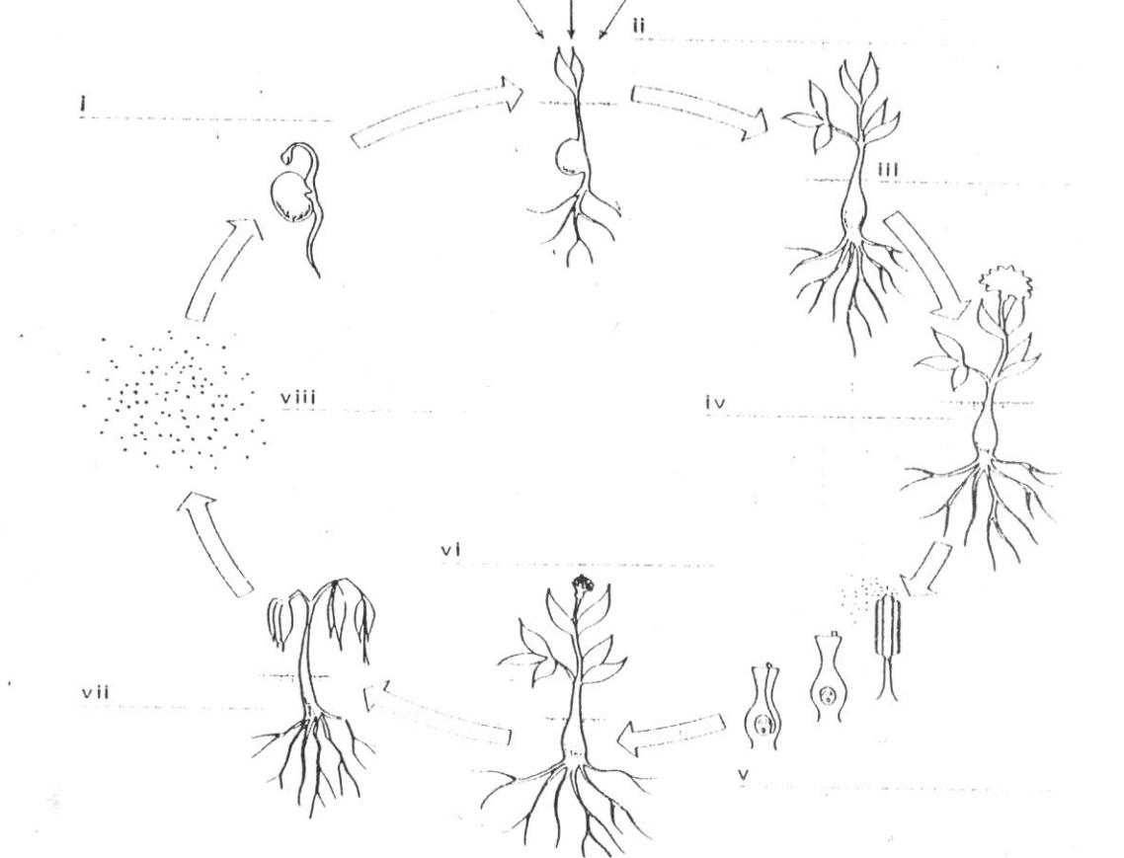

**Figure 1**. The life cycle of a plant

Fruit and seed production

Photosynthesis begins

Plant flowers

Seed dispersal

Decay of vegetative parts

Pollination and fertilization

Stage of rapid vegetable grown

Germination

EXERCISE B:

Look at the following stages in the growth of a plant (the French bean):

A. The seed is dormant.

B. Germination beginsThe seed absorbs water.

The seed swells.

C. The radicle enlarges

The radicle bursts through the testa.

D. The radicle elongates.

E. Lateral roots develop.

The hypocotyl grows.

F. The hypocotyl pulls the cotyledons out of the earth.

G. The plumule remains between the cotyledons.

The hypocotyl straightens.

The cotyledons separate.

H. The cotyledons photosynthesis for a few days.

The cotyledons shrivel.

The cotyledon fall off**.**

**Part 1**:*Time clauses and the conjunctions when, as, after, before, until*

Now read these examples and then complete the sentences:

Example: The seed remains dormant *until* germination begins.

*When* the seed absorbs water, it swell.

1. When the radicle enlarges, ......
2. ...... , lateral roots develop.
3. When the hypocotyl grows, ......
4. The plumule remains between the cotyledons until ......
5. ...... , the cotyledons separate.
6. The cotyledons photosynthesize for a few days until …...

**Part 2:** *Reduced time clauses (conjunction + -ing phrase)*

Look at these sentences

When the seed absorbs Or *On absorbing water,* the

water, it swells seed swells.

After the radicle bursts Or After bursting through

through the testa, it elongates. the testa, the radicle elongates.

Before the hypocotyls Or Before straightening, the

straightens, it grows. hypocotyls grows.

1. Fill in the correct word at the beginning of the following sentences:

1. …... the hypocotyls pulls the cotyledons out of the earth, it straightens.

2. …... the radicle enlarges, it bursts through the testa.

3. …... the cotyledons shrivel, they separate.

1. Now change each of the sentence, using the form *on/before/after +* *…ing*
   1. Use the new structures of the above exercises to write a short paragraph of the germination of the French bean (by linking the stages of its growth).

EXERCISE C: *Nominalisation of verb forms and adverbial phrases of time*

Look at these sentences:

|  |  |  |
| --- | --- | --- |
| After the seed is dormant, it | Or | After *dormancy,* the seed germinate/ *Germination* |
| germinate. |  | occurs. |
| Before the lateral roots develop, | Or | Before *development* of the lateral roots, the radicle |
| the radicle elongates. |  | elongates / *Elongation* of the radicle takes place. |
| As the seed germinates, it absorbs | Or | During *germination*, the seed absorbs water / |
| water. |  | *Absorption* of water occurs. |

Now copy and complete this table. Look up words in your dictionary where necessary.

|  |  |
| --- | --- |
| *Verb* | *Noun* |
|  |  |
| Absorb | …... |
| Dormant | …... |
| Develop | …... |
| Germinate | …... |
| Enlarge | …... |
| Grow | …... |
| Separate | …... |
| Photosynthesize | …... |
|  |  |

**READING TEST:**

Complete the following text by filling in the blank spaces with the expressions given below. A dotted line …... requires a phrase to be added and a straight line ____ requires a word.

|  |  |  |
| --- | --- | --- |
| Root system | rapid growth | may be reduced |
| colder | too high | sufficient air |
| seeds | too much | temperature level |
| temperature | testa | food manufacture |
| germination (3 times) | photosynthesis | well-drained soils |
| downwards | little moisture | dependent on the food store |
| not | in the soil | secondary roots |
| life | water and air | surface of the soil |
| up | destroyed | mature |

The first stage in the life cycle of a plant is ____ . Certain conditions are necessary for ____ to occur. Firstly, the ____ must be alive. If seeds are dried at …... a temperature, the water content in the seeds …... too much and certain essential proteins ____ . Secondly, the amount of moisture in the soil must be right. If there is too …... in the soil, seed will not germinate. However, if there is …... water in the soil, seed will ____ germinate either because wet soil tend to be ____ than drier, ….... This is the third condition necessary for germination to occur. The

…... of the soil must be right. A fourth condition concerns the amount of air …... A wet, badly drained soil may lack …... for seeds to germinate. Thus, we may say that ____ only happens under the right conditions; when there is ____, sufficient …..., and the right ____ .The first stage in the germination of, for example, a bean is the splitting of the ____. The radicle emerges and starts to grow ____. Next, the curved plumule begins to grow ____ toward the light. Meanwhile, the …... is beginning to spread through the soil. In these early stage of development, the seedling is entirely …... in the seed. After the young plant has broken the …...

and the first leaves are produced ….... by ____ can begin. By this time, below the soil surface…... are developing. The plant is ready to begin the stage of …... during which it grows to its full____ size.

**LANGUAGE SUMMARY**

**Using adverb clauses to show time relationships:**

|  |  |  |  |  |  |  |  |  |  |
| --- | --- | --- | --- | --- | --- | --- | --- | --- | --- |
| ***after*** | (a)*After* she graduates, she will get a job. | A present tense, *not* a future tense | | | | | | | |
|  | (b) *After* she (had) graduated, she got a job | is used | | in an adverb | | | clause | | of |
|  | time. Notice example (b) and (d). | | | | | | | |
|  |  |
| ***before*** | (c) I will leave *before* he comes. |
|  |  |  |  |  |  |  |  |
|  | (d) I (had) left *before* he came. |  |  |  |  |  |  |  |  |
|  |  |  | | | | |  |  |  |
| ***when*** | (e) *When* I arrived, he was talking on the phone. | When = at that time | | | | |  |  |  |
|  | (f) *When* I got there, he had already left. | (notice | | the | different | | | time | |
|  | (g) *When* it began to rain, I stood under a tree. | relationship | | | expressed | | by | | the |
|  | tenses) | |  |  |  |  |  |  |
|  | (h) *When* I was in Chicago, I visited the museum. |  |  |  |  |  |  |
|  |  |  |  |  |  |  |  |  |
|  | (i) *When* I see him tomorrow, I will ask him. |  |  |  |  |  |  |  |  |
|  |  |  | | | | | | |  |
| ***While*** | (j) *While* I was walking home, it began to rain. | While, as = during that time | | | | | | |  |
| ***As*** | (k) *As* I was walking home, it began to rain. |  |  |  |  |  |  |  |  |
|  |  |  | | | | | | | |
| ***By the time*** | (l) *By the time* he arrived, we had already left. | By the time = one event is | | | | | | | |
|  | (m) *By the time* he comes, we will already have left. | completed before | | | | another | | event. | |
|  | (notice the use of the past perfect | | | | | | | |
|  |  |
|  |  | and future perfect in the main | | | | | | | |
|  |  | clause) | |  |  |  |  |  |  |
|  |  |  | | | | | | | |
| ***Since*** | (n) I haven‟t seen him *since* he left this morning. | Since = from that time to the | | | | | | | |
|  |  | present. | | (Notice | | the |  | present | |
|  |  | perfect is used in the main clause) | | | | | | | |
|  |  |  | | | | | | | |
| ***Until*** | (o) We stayed there *until* we finished our work. | Until, till = to that time and then | | | | | | | |
| ***till*** | (p) We stayed there *till* we finished our work. | no longer (till is used primarily in | | | | | | | |
| speaking rather than writing) | | | | | | |  |
|  |  |  |
|  |  |  | | | | | | | |
| ***As soon as*** | (q) *As soon as* it stops raining, we will leave. | As soon as, once = when one | | | | | | | |
| ***Once*** | (r) *Once* it stops raining, we will leave. | event | happens, | | | another | | event | |
| happens soon afterwards. | | | | | |  |  |
|  |  |  |  |
|  |  |  | | | | | | | |
| ***As long as*** | (s) I will never speak to him again *as long as* I live. | As soon as, so long as = during | | | | | | | |
| ***So long as*** | (t) I will never speak to him again *so long as* I live | all that | | time, | from beginning | | | | to |
| end. |  |  |  |  |  |  |  |
|  |  |  |  |  |  |  |  |  |
|  |  |  | | | | |  |  |  |
| ***Whenever*** | (u) *Whenever* I see her, I say hello. | Whenever = every time | | | | |  |  |  |
| ***Every time*** | (v) *Every time* I see her, I say hello. |  |  |  |  |  |  |  |  |
|  |  |  | | | | | | | |
| ***The first time*** | (w) *The first time* I went to New York, I went to an opera. | Adverb clauses can be introduced | | | | | | | |
| ***The last time*** | (x) I saw two plays the last time I went to New York. | by the following: | | | |  |  |  |  |
|  | first | |  |  |  |  |  |
| ***The next time*** | (y) The next time I go to New York, I‟m going to see a |  |  |  |  |  |  |
| The | second | | time |  |  |  |  |
|  | ballet. |  |  |  |  |
|  |  | third | |  |  |  |  |  |
|  |  |  |  |  |  |  |  |
|  |  |  | last | |  |  |  |  |  |
|  |  |  | next | |  |  |  |  |  |

**FURTHER PRACTICE**

***A. Complete the following. Pay attention to verb tenses.***

1. Last night I went to bed after I _________ my homework.
2. Tonight I will go to bed after I ______________ my homework.
3. Ever since I was a child, I _________ afraid of dogs.
4. Jane‟s contact lens popped out while she basketball.
5. Be sure to reread your composition for errors before you __________ it in to the teacher tomorrow.
6. By the time I left my apartment this morning, the mail carrier _____ the mail.
7. I have known Jim Bates since he ___________ ten years old.
8. A black cat ran across the road as I ____________ my car to work this morning.
9. By the time I leave this city, I ___________ here for four months.
10. Whenever Mark __________ angry, his nose gets red.
11. I __________ to the beach whenever the weather was fine, but now I don‟t have time to do that because I have to study.
12. We will have a big party when _____________.
13. The next time I _________ to Hawaii, I‟m going to visit Mauna Loa, the world largest volcano.
14. I had fried chicken the last time I ___________ at that restaurant.
15. ***Complete the following sentences. Punctuate carefully. Pay attention to verb tense usage.***
16. Just as I was falling asleep last night ..............................................................
17. I‟ll help you with your homework as soon as I ...............................................

3. .................................................... as long as I live.

1. Just before I ................................................................
2. The last time I .............................................................

6. I had already ................................. when ......................

1. Whenever ....................................................................
2. I will be here until I ......................................................

UNIT 2: PLANTS (2)

2.1. READING AND COMPREHENSION:

**I. Reading text*:***

1. Plants are living organisms consisting of innumerable tiny cells. They differ from animals in many ways but the most important difference is that plants can build up valuable organic substances from simple materials. The most important part of this building process, which is called *photosynthesis*, is the production of *carbohydrates* such as *sugars, starches* and *cellulose.*

**Photosynthesis**

1. In photosynthesis a special green substance called *chlorophyll* uses light energy (normally sunlight) to change *carbon dioxide* and *water* into *sugar* (carbohydrates) in the *green* parts of the plant. The daily amount of photosynthesis is limited by the duration and intensity of sunlight. The amount of carbon dioxide available is also a limiting factor. Shortage of water and low temperatures can also reduce photosynthesis.
2. The cells which contain chlorophyll also have yellow pigments such as *carotene*. Crop plants can also build up chlorophyll in the light and so any leaves which develop in the dark are yellow and cannot produce carbohydrates.
3. *Oxygen* is released during photosynthesis and the process may be set out as follows.
4. This process not only provides the basis for all our food but it also supplies the oxygen which animals and plants need for respiration.
5. The simple carbohydrates, such as *glucose*, may build up to form *starch* for storage purposes, or to *cellulose* for building cell walls. *Fats* and *oils*, are formed from carbohydrates. *Protein* material, which is an essential part of all living cells, is made from carbohydrates andnitrogen compounds.

**The parts of a plant**

1. Most plants consist of *roots, stems, leaves* and *reproductive parts* and need *soil* in which

to grow.

1. The root spread through the spaces between the particles in the soil and anchor the plant. In a plant such as wheat the root system may total many miles.
2. The leaves, with their broad surfaces, are the main parts of the plant where photosynthesis occurs (see Figure 2)

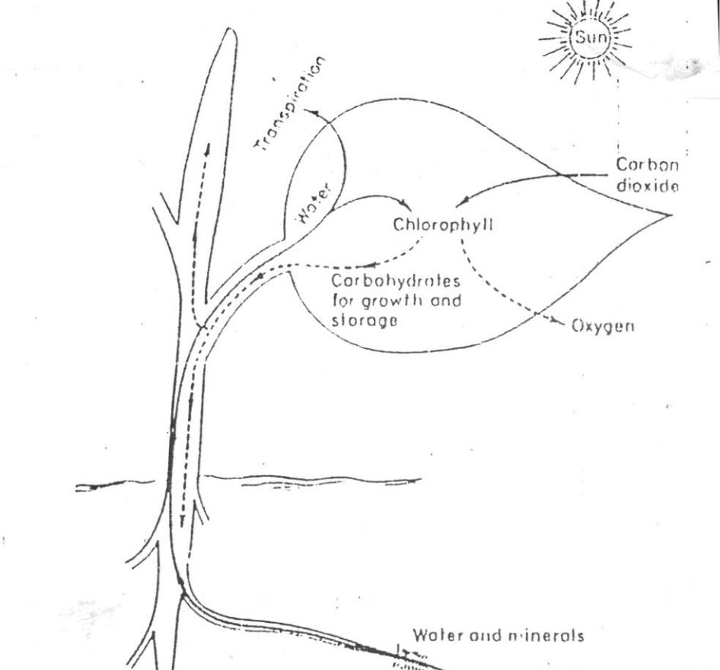

**Figure 2.** Photosynthesis illustrated diagrammatically

1. A very important feature of the leaf structure is the presence of large numbers of tiny pores (*stomata*) on the surface of the leaf (see Figure 3)

There are usually thousands of stomata per square cm of leaf surface. Each pore (stoma) is oval-shaped and surrounded by two guard cells. When the guard cells are turgid (full of water) the stoma is open and when they lose water the stoma closes.

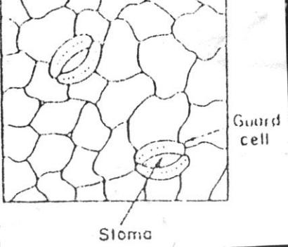

**Figure 3**. Stomata on leaf surface.

**11** The carbon dioxide used in photosynthesis*diffuses*into the leaf through the stomata andmost of the water vapour leaving the plant, and the oxygen from photosynthesis diffuses out through the stomata.

**Transpiration**

**12** The evaporation of water from plants is called*transpiration*. It mainly occurs though thestomata and has a cooling effect on the leaf cells. Water in the cells of the leaf can pass into the pore spaces in the leaf and then out through the stomata as water vapour (see Figure 4).

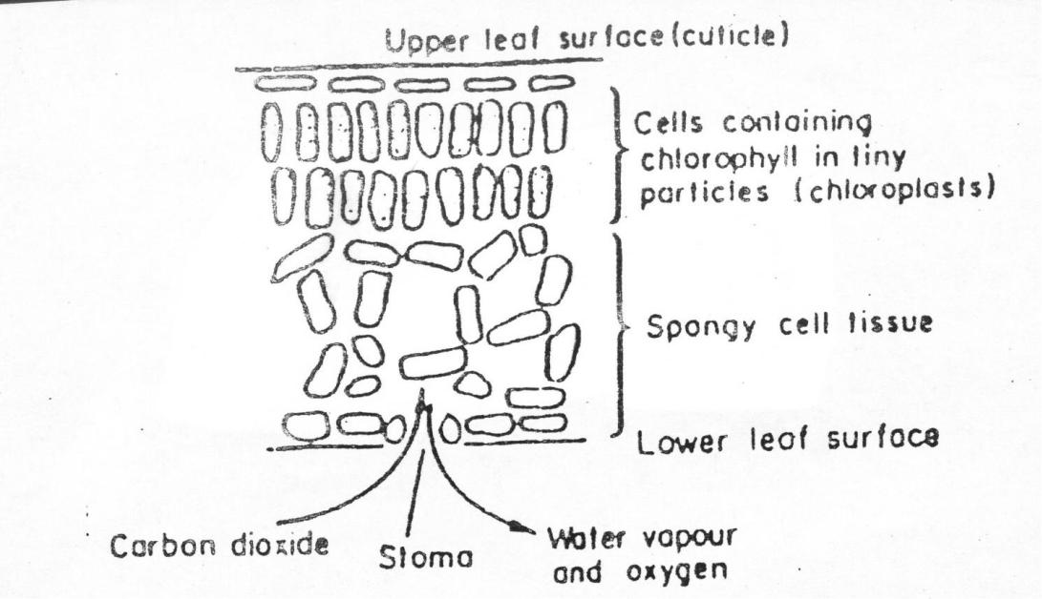

**Figure 4**. Cross-section of green leaf showing gaseous movements during daylight.

1. The rate of transpiration varies considerably. It is greatest when the plant is well supplied with water and the air outside the leaf is warm and dry. In very hot or windy weather water evaporates from the guard cells and so the stomata close and reduce the rate of transpiration. The stomata also close in very cold weather, e.g. 0 0C.
2. The rate of loss is reduced if the plant is short of water because the guard cells then lose water and close the stomata; it is also retarded if the humidity of the atmosphere is high.
3. The stomata guard cells close (and so transpiration ceases) during darkness. They close because photosynthesis ceases and water is lost from the guard cells (osmosis) when some of the sugars present change to starch.

(Adapted from Lockhart & Wiseman, *Introduction to Crop Husbandry*, Pergamon Press)

2.2. Comprehension questions:

*Now read the text carefully, looking up any new items in a dictionary or reference book.*

*Then answer the following questions:*

1. What is the main difference between plants and animals ?
2. What is starch an example of ?
3. What decides how much photosynthesis take place in a day ?
4. What is the reason for crop plants having yellow leaves ?
5. What do plants mainly consist of ?
6. Where do you find stomata ?
7. How does oxygen come out of a plant ?
8. What else comes out of a plant ?
9. Why do stomata close in hot weather ?
10. Why does photosynthesis not take place in darkness ?

2.3. Vocabulary:

1. In the first paragraph, what these words refer to:

 Line 1: They

 Line 4: which

1. In the paragraph 1, which words in the text have the same meaning as:

Very small

Cannot be counted

not complicated

1. In paragraph 2, what words have the opposite meaning to:

 cannot be obtained

 excess

 increase

1. In paragraph 2, which words have the same meaning as:

 length of time

 alter

 quantity

1. Look at paragraph 3,4 and 5 and explain the following words:

 chlorophyll

 carotene

 respiration

1. In paragraph 6, which words correspond to the definitions ?

 a tiny unit of living matter

 something made up of two or more combined parts

 a body-building substance which is important for good health

 necessary

1. In paragraph 7,8 and 9, which words have the opposite meaning to:

 narrow

 does not happen

1. Look at paragraph 10 and 11, explain the following words:

structure

surface

diffuses

vapour

2.4. EXERCISE

A: *The form of definitions*

Definitions often take one of the following forms:

1. [A] is/are, may be defined as [B] which [C].

E.g. [A The embryo] is / may be defined as [B the part of a flower] which [C will develop into another plant]

2. [B] which [C] is/are called, is/are known as [A].

E.g. [B The part of a flower] which [C will develop into another plant] is called /is known as [A the embryo].

Expand the following into full definitions using the patterns illustrated above

|  |  |  |  |
| --- | --- | --- | --- |
|  | A | B | C |
| 1.Photosynthesis | | The process | Transforms light energy from the sun |
|  |  |  | into chemical energy. |
| 2.A soil profile | | A succession of soil | Extends from the surface of the soil to |
|  |  | horizons | the parent rock. |
| 3. | Aerobic bacteria | Organisms | Can live in the presence of air. |
| 4. | Osmosis | Biophysical process | Take place through the tissues of |
|  |  |  | living plants. |
| 5. | A leaf | Complex structure | Utilizes energy from the sun in the |
|  |  |  | manufacture of food. |
| 6. | Chloroplasts | Bodies | Absorb sunlight and manufacture |
|  |  |  | food. |
| 7. | Stomata of plants | Minute openings on the | Lead to the interior of the leaf and the |
|  |  | surface of a leaf | chloroplasts. |
| 8. | Chlorophyll | The chemical | Enable sunlight to convert carbon |
|  |  |  | dioxide into food and other |
|  |  |  | substances. |

EXERCISE B: *The impersonal passive*

Examine the following active and passive sentences, and note the verb form of each passive sentence. Note that the words in brackets are optional, and are often omitted in scientific writing.

Now, write down the passive version of the following active sentences. Then combine the passive sentences you have written following the clues provided.

E.g. A: The tiny root hairs absorbed water and mineral. An increase in the number of root hairs increases the power of absorption.

* 1. Water and mineral *are absorbed* by the tiny root hairs. Therefore, the power of absorption *is increased* by an increase in the number of root hairs.

1. *A*: The fruit encloses the seeds. The fruit protects them while they are developing.

*P*: The seeds ... by the fruit. Consequently, they ...while they are developing.

1. *A*: The plant takes in oxygen. The plant uses oxygen to break down carbohydrates.

*P*: Oxygen ... in by the plant and ... to break down carbohydrates.

1. *A*: Wind and insects transfer pollen from one flower to another. They deposit the pollen on thestigmas of the other flower.

*P*: When pollen ... by the wind and insects from one flower to another, it ... on the stigmas ofthe other flower.

1. *A*: The human body requires small quantities of several minerals. The human body obtainsthese minerals from plants.

*P*: Small quantities of several minerals which are ... by the human body ... from plants.

1. *A:* We can use some roots to reproduce the species. We should remove the whole root ofharmful weeds such as docks instead ploughing them in lightly.
   1. Some roots ... to reproduce the species. Thus, the whole root of harmful weeds such as docks ... instead of ... lightly.
2. *A:* Soil texture influences all aspects of root development. A heavy compact soil creates aphysical barrier to root growth.
   1. All aspect of root development ... by soil texture. For example, a physical barrier to root growth ... by a heavy compact soil.
3. *A:* Too much cultivation destroys the soil structure.

A pasture phase under grass can improve the structure.

*P:* Since soil structure ... by too much cultivation, the structure ... by a pasture phase undergrass.

1. *A:* The plant manufactures food from chemical substances present in the soil & air.The roots take in chemical substances from the soil.

The leaves take in carbon dioxide from the air.

*P:* Food is ... by the plant from chemical substances which ... from the soil by the roots andfrom carbon dioxide which ... from the air by the leaves.

9. *A:* We can use a unit called a soil profile to describe soils.

When we wish to compare two soils, we examine their profiles.

We can define a soil as having an individual profile.

*P:* A unit called a soil profile ... to describe soils. So when we wish to compare two soils,their profiles ..., and each soil can thus ... as having an individual profile.

1. *A:* Ploughing „turn in‟ the whole surface of a field.

It buries and kills the weeds

It loosens and exposes the soil to the air.

*P:* The whole surface of the field „.....‟ by ploughing, with the result that weeds ... and ...and the soil ... and ... to the air.

EXERCISE C: *Make statements*

Use the following verbs in the correct form to complete the paragraph below:

*carry, be help, perforate, carry, be, not lignify,*

*usually find, form, thicken, make, know.*

E.g. Plants *take in* oxygen which *combines* with organic foodstuffs.

Crops *are checked* in growth if the roots *are deprived* of oxygen.

The movement of materials through the plant ........ as *translocation*. The *xylem* or *wood vessels* which ....... the water or mineral salts from the root to the leaves ......... tubes. These tubes....... from dead cells. The cross walls of the cells have disappeared and the longitudinal walls ......with *lignum*. These ........ wood. The tubes ........ to strengthen the stem. The *phloem tubes (bast*)........ organic material through the plant. These vessels ..... chains of living cells which .........They have cross walls which ......... -hence the alternative name, *sieve tubes*. In the stem the xylem and phloem tubes ........ in a ring near the outside of the stem.

2.5. LANGUAGE IN USE

EXERCISE A: *Understanding discourse*

If you do not understand something, you can ask for an explanation in a number of ways.

Look at this table:

|  |  |  |  |
| --- | --- | --- | --- |
| (Excuse me) | can you | explain ............ |  |
| (I‟m sorry, but) | could you | tell me a bit more about ............... | |
|  |  |  |  |
|  | I don‟t really understand ..... | |  |
|  | could you (possibly/please) repeat | | that last bit ........ |
|  |  |  | what you just said ...... |
|  |  |  |  |

Imagine you do not understand the following terms. Ask each other for an explanation.

- stomata - evaporation - photosynthesis - osmosis - transpiration - root hair

EXERCISE B: *Labeling the diagrams*

Complete the labeling of the following diagrams by inserting the correct labels from the list of words and phrases below:

I. a) secondary root develop

b) root system spreads through soil

c) split testa

d) photosynthesis can begin

e) plumule

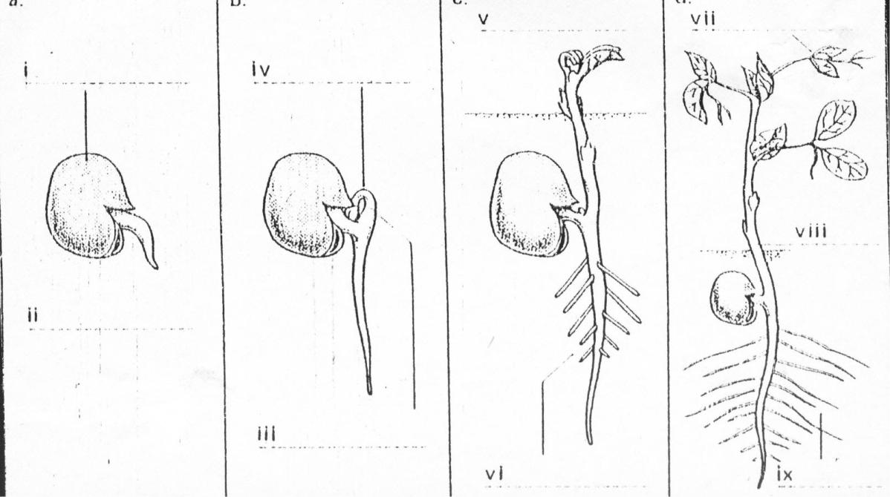

f) radicle

g) curved to protect growing point

h) leaves sprouting

i) main shoot

**Figure 5**.*The germination of a broad bean.*

II. a) water from soil d) sunlight

b) carbon dioxide taken in e) oxygen given off as gas

c) sunlight used to assist combination of CO2 and H2O

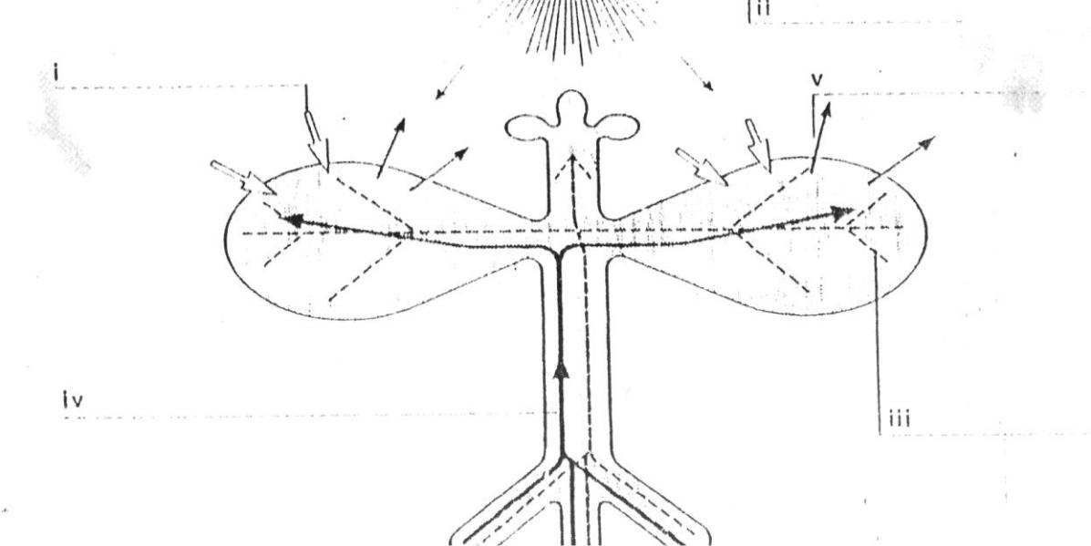

**Figure 6.** *Photosynthesis.*

EXERCISE C: *General statements of function*

We can make general statements about the function of different parts of a plant by naming them and saying what their function is.

*Pair work:* One student puts question for each part of a plant and the other answers bymaking the general statement of function in two ways.

1. Stem / support the shoot system.
2. Fruit / protects the ripened, or matured, ovary.
3. Stamens / produce the male sex cells, or spermatia.
4. Embryo / develop into an adult plant.
5. Leaves / manufacture sugars and other carbohydrates by photosynthesis.
6. Root / anchor the plant in the soil and absorb water and minerals.
7. Sepals / protect the flower while it is in the bud stage.

8.Foodstore / produce the nourishment for the growing embryo.

**READING TEST**:

Complete the following text by filling in the blank spaces with the expressions given below. A dotted line ....... requires a phrase to be added and a straight line _____ requires a word to be added.

|  |  |  |
| --- | --- | --- |
| roots | shoot system | soil |
| soil air | carbon dioxide | photosynthesis |
| made up of | ripened ovary | water and minerals |
| carbohydrates | living | such as |
| function | specialized | more fertile |
| by | reproductive organs | consists of |
| their roots | organic materials | process |
| conversion | are produced |  |

A plant is a living organism ...(1)... different parts each of which has a _____ function. The basis parts of a plant are the root system and the ..(2).... .

The root absorbs water and minerals from the __(3)___. Plants such as sugar beet and carrots store food in ...(4)... Leguminous plants ...(5)... clover and lucerne have special bacteria __(6)___ on their roots which take nitrogen out of the ..(7)... Consequently, when they are ploughed under, the soil is made ...(8)...

The shoot system ...(9)... the stem, the leaves, flowers and fruit. An important __(10)___ of the stem is to enable ...(11)... to pass up to the leaves and flowers and ..(12)... such as sugar to travel down to the __(13)___. In the leaves __(14)___ takes place. The process results in the of water from the soil and ...... from the air into sugar and other __(15)___. During the __(16)___

oxygen is formed and released into the air. The plant‟s ...(17)... are contained in the flower. The spermatia ..(18).... by the stamens and the ovules are produced __(19)___ the carpel. The fruit, the ...(20).. of the flower, encloses and protects the seeds.

**LANGUAGE SUMMARY**

**Using the passive**

Example: (a) Rice is growing in India.

1. Our house was built in 1980.
2. The olive oil was imported from Spain.

Usually the passive is used without a “by phrase” . The passive is most frequently used when it is not known or not important to know exactly who performs an action.

In (a) : Rice is grown in India by people, by farmers, by someone. In sentence (a) it is not known or important to know exactly who grows rice in India. (a), (b) and (c) illustrate the most common use of the passive, i.e., without the “by phrase”.

(d) Life on the Mississippi was written by Mark Twain.

The “by phrase” is included only if it is important to know who performs an action.

In (d), *by Mark Twain* is important information.

1. My aunt made this rug. (active)
2. This rug was made by my aunt.

This rug was made by my mother.

If the speaker/writer knows who performs an action, usually the active is used, as in (e).

The passive may be used with the “by phrase” instead of the active when the speaker/writer wants to focus attention on the subject of a sentence. In (f) the focus of attention is on two rugs.

**FURTHER PRACTICE**

Change the following active sentences to passive sentences if possible. (some of the verbs are intransitive and cannot be changed). Keep the same tense. Include “by phrase” only if necessary.

1. People grow corn in Iowa. => *Corn is grown in Iowa.*
2. Peter came here two months ago. (*no change*)
3. Someone made this antique table in 1734.
4. An accident happened at the corner of Fifth and Main.
5. Someone stole my purse.
6. Someone was making the coffee when I walked into the kitchen.
7. Translators have translated that book into many languages.
8. Jim‟s daughter drew that picture. My son drew this picture.
9. The judges will judge the applicants on the basic of their originality.

10. My sister‟s plane will arrive at 10.35.

11. Is professor Rivers teaching that course this semester?

12. When did someone invent the radio?

13. The mail carrier had already delivered the mail by the time I left for school this morning.

14. When is someone going to announce the results of the contest ?

15. After the concert was over, hundreds of fans mobbed the rock music star outside the theater.

16. Ever since I arrived here, I have been living in the dormitory because someone told me that it was cheaper to live there than in an apartment.

17. They are going to build the new hospital next year. They have already built the new elementary school.

18. If you expose a film to light while you are developing it, you will ruin the negatives.

-------------------------------

**Using English to define**

Aristotle suggested that a good definition should include the general classification og a term plus the specific characteristics that differentiate the term from other members of its class. For example, a definition of a giraffe should include a classification, such as, *A* *giraffe is an animal,* and specific characteristics, such as, *A giraffe is tall, African animal with a very long neck.*

**Definition formula:**

**Term = Class + characteristics**

Example: *Chemical energy is potential energy that is stored in gasoline, food, and oil.*

(Frequently, the characteristics appear as a relative clause beginning with *which, that,* *who, or where)*

Chemical energy = potential energy + that is stored in gasoline, food and oil.

(term) (class) (characteristics)

**Relative clauses:**

A clause is a part of a sentence that contains a noun and a verb. A relative clause is one that begins with which, that, where, or who. Which and that are most commonly used in science definitions; who is used when referring to people. Science definitions often include relative clauses containing the characteristics that distinguish an item from others in the class.

**Formulating definitions**: Using the information given in each series, write a definition.

Use the sentence patterns above to guide you.

1. an amoeba / one-celled animal / constantly change its shape.

*An amoeba is a one-celled animal that constantly changes its shape*.

1. an antibiotic / drug / cures bacterial diseases.
2. lung / organ / breathing.
3. acoustics / science / sound.
4. photosynthesis / process / plants manufacture food.
5. catalyst / substance / speeds up but is not changed by a chemical reaction.
6. calorie / unit / measures heat.
7. cyclotron / apparatus / bombards the nuclei of atoms.

**Creating definitions**: A good way to see if the definition is complete is to reverse it. Forexample, if we reverse an elephant is an animal, we get an animal is an elephant, and it is obvious that the definition for each of the following words and test each one by reversing it. If you need help, use a dictionary.

UNIT 3: SOILS

# 3.1. READING AND COMPREHENSION

**I. Reading text:**

1. Soils are very complex natural formations which make up the surface of the earth. They provide a suitable environment in which plants may obtain *water, nutrients* and *oxygen* for root respiration, and firm *anchorage*. Soils are formed by the weathering of rocks, followed by the growth and decay of plants, animals, and soil micro-organisms. If a farmer is to provide the best possible conditions for crop growth, it is desirable that he should understand what soils are, how they were formed and how they should be managed.
2. The *topsoil* or *surface soil* is a layer about 8 - 45 cm deep which may be taken as the greatest depth which a farmer would plough or cultivate and in which most of the plant roots are found.
3. Loose, cultivated, topsoil is sometimes called *mould.*

The *subsoil,* which lies underneath, is an intermediate stage in the formation of soil from the rock below.

**Soil profiles**

1. A *soil profile* is a section taken through the soil down to the parent rock. In some cases this may consist of only a shallow surface soil 10 - 15 cm on top of a rock such as chalk or limestone. In other well-developed soils (about a metre deep) there are usually three or more definite layers (or horizons) which vary in colour, texture and compaction (see Figure 7.).
2. The soil profile can be examined by digging a trench or by taking out cores of soil from various depths with a *soil auger.*
3. A careful examination of the layers (horizons) can be useful in forming an opinion as to how the soil was formed, its natural drainage and how it might be farmed. Some detailed soil classifications are based on soil profile.

**Soil formation**

**7** There are very different types of soils and subsoils. The differences are mainly due to thevariety of rocks from which they are formed. However, other factors such as *climate, topography,* *plant and animal life, the age of the developing soil material* and *farming operation* also affectthe type of soil which develop.

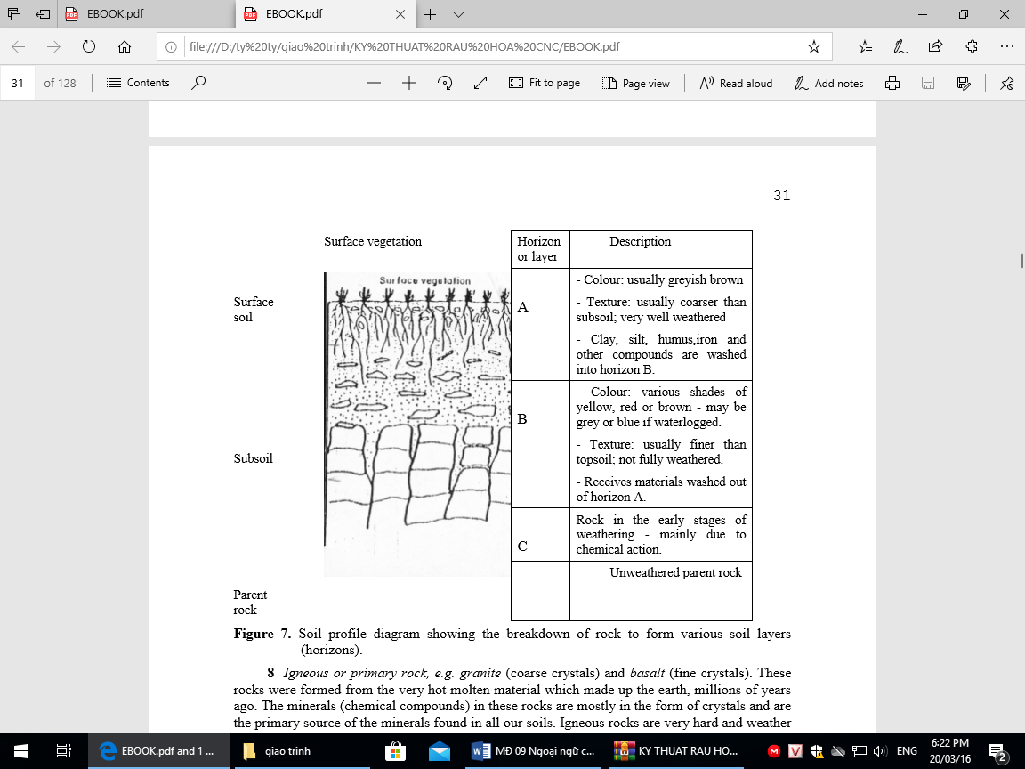

1. *Igneous or primary rock, e.g. granite* (coarse crystals) and *basalt* (fine crystals). Theserocks were formed from the very hot molten material which made up the earth, millions of years ago. The minerals (chemical compounds) in these rocks are mostly in the form of crystals and are the primary source of the minerals found in all our soils. Igneous rocks are very hard and weather very slowly. Clay and sand are breakdown products.
2. *Sedimentary or transported rocks.* These have been formed from weathered material (e.g.clay, silt and sand) carried and deposited by water and wind. The sediments later became compressed by more material on top and cemented to form new rocks such as *sandstones, clays* and *shales.*
3. The *chalks* and *limestones* were formed from the shells and skeletons of sea animals of various sizes. These rocks are mainly calcium carbonate. The calcareous soils are formed from them.

**11** *Metamorphic rocks e.g. marble*(from limestone) and*slate*(from shale). These are rockswhich have been changed in various ways.

**Weathering of rocks**

The breakdown of rocks is mainly caused by the *physical* and *chemical* effects of the weather.

**12** *Physical weathering. Changes of temperature*cause the various mineral crystals in rocksto expand and contract by different amounts, and so cracking and shattering often occurs.

**13** *Wetting and drying*of some rocks such as clays and shales causes expansion andcontraction and results in cracking and flaking.

**14** *Chemical weathering.*Chemical breakdown of the mineral matter in a developing soil isbrought about by the action of water, oxygen, carbon dioxide and nitric acid from the atmosphere; and by carbonic and organic acids from the biological activity in the soil. The soil water, which is a weak acid, dissolves some minerals and allows chemical reactions to take place.

**15** Water can also unite with substances in the soil (hydration) to form new substanceswhich are more bulky and so can cause shattering of rock fragments. Clay is produced by chemical weathering. In the case of rocks such as granite, when the clay-producing parts are weathered away the more resistant quartz crystals are left as sand or silt.

**16** In badly drained soils, which become water-logged from time to time, various complexreactions (including a reduction process) occur and are referred to as *gleying*. This process which is very important in the formation of some soils results in ferrous iron, manganese and some trace elements moving around more freely and producing colour changes in the soil. *Gley* soils are generally greyish in colour (may also be green or blue) in the waterlogged regions, but rusty-coloured deposits of ferric iron also occur in root and other channels, and along the boundaries between the waterlogged and aerated soil, so producing a mottled appearance (hence the Russian name „gley‟). Glazing or coating of the soil structure units with fine clay is also associated with gleying.

(Adapted from Lockhart & Wiseman, *Introduction to Crop Husbandry*, Pergamon Press)

3.2. Comprehension questions:

Now read the text carefully, looking any new items in a dictionary or reference book. Then answer the following questions:

1. What are the four main constituent parts of soil ?
2. What should the farmer understand about soil ?
3. How are soils formed ?
4. What is a soil profile ?
5. How do you take a soil sample ?
6. What can a soil sample tell you ?
7. How is sand formed ?
8. What are the two main causes of physical weathering ?
9. What causes chemical weathering ?
10. What is the cause of gleying ? and what is the normal colour of a gley soil?

3.3. Vocabulary:

1. Look at the par.1 and say what words have the opposite meaning to:

simple loose

not wanted macro-

1. Look at par.2 and say what the words „which‟ (used 3 times) refer to
2. Look at par. 3, 4, 5, 6 and say which words correspond to the definitions:

 How particles are arranged in a substance

 The process of pressing particle closely together

 A ditch dug in the ground

 The middle, or most important, part of any thing

 A system for taking away water

 A group into which something is put

1. Look at par. 7, can you explain the words:

climate topography

1. Look at par.8, is this statement correct or in correct ?

„Crystals are not found in igneous rocks‟

1. Look at par.9, 10, 11, what words have the same meaning as:

 put down

 pressed together

 of different kinds

1. Look at par.12, What words have the same meaning as:

grow larger

grow smaller

happen

1. Look at par.16, What words have the same meaning as:

 usually

 edges/limits

3.3. EXERCISE

EXERCISE A: *Adjectives and Adverbs*

E.g. The air found in the soil is *really atmospheric* air which has been changed by *various* *chemical* reactions.

Complete the following the paragraphs using the words in brackets in their correct adjectival or adverbial form:

Aeration is the replacement of (stagnant) _____ air in the soil with (fresh) _____ air. The process is (main) _____ brought about by the movement of water into and out of the soil. Then, as the surplus water soaks down to the drains or is taken up by plants, (fresh) _____ air is drawn into the soil to refill the pore spaces.

The aeration process is assisted by

1. changes in temperature
2. changes in (barometric) _____ pressure.
3. (good) _____ drainage,
4. cultivation (especial) _____ on clay soil,
5. (open) _____ soil structure.

Sandy soils are (normal, good) _____ _____ aerated because of their (open) _____structure. Clay soils are (usual, poor) _____ _____ aerated (particular) _____ when the very (small) _____ pores in such soils become filled with water. (Good) _____ aeration is (vital, important) _____ _____ for germinating seeds and seedling plants.

EXERCISE B: *Comparative Sentences*

E.g. a) Particles of fine sand are *coarser than* particles of clay.

* Particles of clay are *not as coarse as* particles of fine sand.
  1. Transported soils are *more common than* sedentary soil in humid regions.
* Sedentary soils are *less common than* transported soils in humid regions.

Compare the information presented in the tables and diagram below using the adjectives given. Use *ADJ-er + than* and *not as ADJ as* constructions to express the comparison.

1. Look at table 1, compare the particle size of a) fine sand with silt (fine)

b) clay with fine sand (coarse) c) fine sand with gravel (coarse)

**Table 1.**

|  |  |  |
| --- | --- | --- |
| Soil particles | Diameter (mm) | |
|  |  | |
| Gravel | 2.0 or more | |
| Coarse sand | 2.0 | - 0.2 |
| Fine sand | 0.2 | - 0.02 |
| Silt | 0.02 - 0.002 | |
| Clay | 0.002 or less | |
|  |  |  |

1. Look at table 2 and compare these soils in terms of *more* or *less* acidity or alkalinity.
   1. A soil with a pH value of 4.0 with a soil with a pH value of 6.5
   2. A soil with a pH value of 8.0 with a soil with a pH value of 9.8

**Table 2.** The pH scale

|  |  |  |  |  |  |
| --- | --- | --- | --- | --- | --- |
| 4 | 5 | 6 | 7 | 8 | 9 |
| *strongly* | *moderately* |  | *neutral* | *moderately* | *very* |
| *acid* | *acid* |  |  | *alkaline* | *alkaline* |
|  | |  |  |  |  |
| Most soil in | |  |  |  | occur only in |
| humid regions | |  |  |  | arid regions |
| when not limed | |  |  |  |  |

1. Look at table 3 and compare the contents of these soils in terms of
   1. Their sand content
   2. Their silt content
   3. Their clay content
   4. Their humus content

Begin the statement as follows:

1. The percentage of sand/silt etc. in a light sandy soil
2. The sandy/silt etc. content of a heavy clay soil ....................
3. A light sandy soil has .............................

**Table 3.**

|  |  |  |
| --- | --- | --- |
| *A: light sandy soil* |  | *B: heavy clay soil* |
|  |  |  |
|  | % | % |
| gravel | 1.2 | 1.3 |
| sand | 37.4 | 33.7 |
| silt | 38.6 | 26.9 |
| clay | 11.8 | 28.3 |
| humus | 4.5 | 7.8 |
| other contents | 6.5 | 2.0 |
|  |  |  |

1. Using the information in table 4 to compare the characteristics of the top soil and the sub-soil in terms of
2. colour: (i) The top soil is ................
   1. The sub-soil is ..............
3. particle sizes: (i) The particle sizes of the top soil ........................
   * 1. The particle sizes of the sub-soil ........................

c) Living organisms: (i) There are ............ in the top soil ..................

(ii) There are ............ in the sub-soil ................

1. elements for plant food: (i) The top soil is ...............
   1. The sub-soil is ...........................

**Table 4:**

|  |  |  |
| --- | --- | --- |
|  | *Top soil* | *Sub-soil* |
|  |  |  |
| Colour | Dark | Light |
| Particle sizes | Coarse | Fine |
| Living organisms | Many | Few |
| Elements for plant food | Rich | Poor |
|  |  |  |

EXERCISE C: *Making Comparisons by Inference*

Study the following short passage and complete the statements about it below.

The soil microbes which decompose organic materials grow best at pH 6.5. Near this pH, conditions are best for the availability of most plant nutrients. As the acidity increases, the availability of nearly all important nutrients diminishes. Phosphorous, in particular, is held as insoluble compounds in highly acid soils. As acidity decreases (i.e. as pH rises) iron, manganese, copper and zinc grow scarce. Most upland soils developed under forests in humid regions are too acid for the best growth of pasture grasses, vegetables and many other plants.

Write *less* or *fewer* or *not as good* or *higher* in the spaces provided:

1. At a pH value of below 4 there are .............. important nutrients in the soil.

2. There is .......... soluble phosphorous in highly acid soils.

3. Iron, manganese, copper and zinc are ............ available in ......... alkaline soil.

4. Vegetables prefer conditions of ..... acidity than is found in most upland soils.

5. Conditions are ............ for the decomposition of organic materials by soil microbes at low pH soil values

# 3.4. LANGUAGE IN USE

EXERCISE A: *Making tables from descriptions.*

Read this description of a soil profile.

Profile of Soil A: Red Earth

The A horizon extends to a depth of 36cm. A soil consists of a brownish red sandy loam. It has a porous and friable granular structure which is mixed with pebbles. The B horizon extends from the 36cm to 130cm and is red in colour. It is a sandy loam, gravelly in structure with large quantities of pebbles. The C horizon, which extends down to 244cm, has a yellowish white colour. It is sandy, with a structure which is a cemented and compact mass, made up of decomposed felspars.

Now study the following table which summarizes the information presented in the description above.

*Profile of Soil A: Red Earth*

|  |  |  |  |  |  |  |
| --- | --- | --- | --- | --- | --- | --- |
| *Horizon* | *Depth cm* | *Colour* | *Soil* | *type* | *Structure* | *Other features* |
|  |  |  | *(textural class)* | |  |  |
|  |  |  |  | |  |  |
| A | 0 -36 | brownish | sandy loam | | porous and | mixed with pebbles |
|  |  | red |  |  | friable granular |  |
|  |  |  |  | |  |  |
| B | 36 - 130 | red | sandy loam | | gravelly | mixed with large |
|  |  |  |  |  |  | quantities of pebbles |
|  |  |  |  |  |  |  |
| C | 130 - 144 | yellowish | sandy |  | cemented and | decomposed felspars |
|  |  | white |  |  | compact mass |  |
|  |  |  |  |  |  |  |

Read the following description of soil profiles and make tables presenting the information as in the example above.

1. *Profile of Soil B: Laterite*

The A horizon extends down to 61cm. Its colour is brownish deep red. The textural class of the soil is clay loam. It has a loose granular structure which is mixed with gravel. The B horizon which extends from 61cm to 259cm is a clay loam. It is bright red with a gravelly laterite structure. The C horizon below 259cm is red, mottled with yellow and whitish colours. It is rocky consisting of honey-combed laterite.

2. *Profile of Soil C: Mountain and Hill Soil*

The A horizon extends to a depth of 18cm. Light brownish grey in colour, the soil type is a sandy loam with a friable granular structure. Another feature is that it is slightly sticky when wet. The B horizon extends from 18cm to 66cm. It is yellowish brown in colour and consists of a moist clay loam having a blocky, very hard and compact structure. It is also sticky when wet. The C1 horizon goes down to 97cm and is yellowish brown in colour. A moist clay loam, the soil has a blocky, extremely firm structure which is difficult to cut. It is very sticky when wet, and some parent material is mixed with the soil. Below 97cm, the C2 horizon is yellowish brown, a clay loam which is soft and easy to cut when moist. It has a laminated and compact clay shale structure.

EXERCISE B: *Writing description from table*

Study the following table and then complete the paragraph below describing soil profile D.

................. extends to a depth of ..................... in colour, the soil type is ............. with a ................ structure. A feature is the presence of ................ extends from and is ............ in colour. It consists of a ............... having a .............. The B horizon goes down to ............... and is .............. in colour. The textural class of the soil is a ............... The soil has a .............. which contains ............ Below 137cm the C ................ is ................, a .....................

**READING TEST:**

Complete the following text by filling in the blank spaces with the expressions given below. A dotted line ....... requires a phrase to be added and a straight line _____ requires a word to be added.

|  |  |  |
| --- | --- | --- |
| *is derived from* | *mixture* | *property* |
| *composition* | *composed of* | *sizes* |
| *non-solid* | *therefore* | *solids* |
| *chemical decomposition* | *sub-soil* | *soil particles* |
|  | *water and air (2)* | *organic matter* |

The soil system is made up of mineral particles which are mixed with decomposed ...... The

top soil consists of this ____, which is so vital for plant growth. Below the top soil is the ____which is largely .......... mineral matters. In addition to the mineral and organic matter, called the soil ____, there are spaces between the ......... which are taken up by ......... , and make up the____ part of the soil. The accompanying diagram shows the volume ____ of a typical top soil.

Amounts are approximate as the percentage of certain constituents e.g. ..............., is constantly varying.

UNIT 4: FARM MANAGEMENT

4.1 Reading text:

Management is the key ingredient. The manager „make‟ or „break‟ a business. Brain are more important than brawn. How often have you heard these or similar statements or read them in farm magazines? They all emphasize an important factor in the operation of a farm or ranch in today‟s world. *Management is important*. This does not mean that management was not important in the past. However in agriculture which is highly mechanized, uses many technological innovations, and operates with large amounts of borrowed capital, management takes on a new dimension and importance.

Why do some farmers make more money than others? Why do some farm businesses grow and expand while others struggle to maintain their current size? Good or bad luck can not explain all the differences observed in the profitability of farms and ranches even among those which have about the same amount of land and capital available. Farm business records from many states show the top one-third of the farm to be highly profitable while the bottom one-third are often operating as a loss. Why the difference? Observation and analysis often lead to the same conclusion. The difference is due to management.

These differences in management can show up in three areas: production, marketing and financing. Production differences include the choice of agricultural commodities to be produced and how they are produced. Marketing includes the when, where, and how of purchasing inputs and selling commodities. Differences here are reflected in different prices paid and received. Financing covers not only borrowing money and the related questions of when, where, and how much, but also the entire area of how to acquire the resources necessary to produce agricultural commodities. There is risk to be considered in all three areas – how farm managers adapt to and handle this risk can have a major impact on profit.

If management is so important, we must ask even more questions. What exactly is management? What do managers do ? what is the difference between management and labor ? what knowledge and skills are needed to become a better manager ?

**Farm and ranch management**

There are some differences in the management of a farms or ranch and a management of a non-farm business corporation. The obvious differences are in size, type of business, and the products or services produced. Other differences include the relationship between labor and management and the setting of goals.

In a corporation, the board of directors sets policies and goals and hires managers to achieve them. It is generally easy to separate corporation employees who are managers from those who provide the labor necessary to produce a product or provide a service. On a typical farm or ranch, one individual or a family group sets the goals, provides the management, and performs much or all of the labor required. This makes it difficult to separate the management activity from labor because the same individuals are involved and both tasks may be performed at the same time. For example, a farmer may be mentally planning a marketing strategy or developing next year‟s cropping program while operating a tractor or combine. When one person performs both the management and labor functions, there is a danger that the immediate need for labor to perform some task will place management in a secondary role, with management decisions postpones or delayed.

These differences are not readily apparent when definitions of business management and farm and ranch management are compared, but they are nevertheless important. There are many different textbook definitions of farm and ranch management, but several common points run through all of them. One of the more concise definitions is „Farm management is concerned with the decisions which affect the profitability of the farm business‟. This broad definition contains several important points. First, it identifies profitability as a major objective of the business but not necessarily to the exclusion of other objectives. Second, this definition specifically identifies decisions and decision making as part of the management process.

Other farm management texts contain alternative definitions but with many of the same concepts or ideas. There is usually some reference to *decisions* or *decision making* as being part of management process. Also some mention is made of *goals* or *objectives*. This may be done in general terms, or a more specific goal such as profit maximization may be identified as being an important end to which the management effort is directed. Finally, some mention of the *organization* and *operation* of the farm or ranch business is included in many definitions.

Farm and ranch management can be thought of, then, as being a decision-making process. It is a continual process because of the continual changes taking place in our economy and in an individual business. The decision are concerned with allocating the limited resources of land, labor, and capital among alternative and usually competing uses. This allocation process forces the manager to identify goals and objectives to guide and direct the decision making.

In this text, the following definition will be adopted: *farm and ranch management is the* *decision-making process whereby limited resources are allocated to a number of production alternatives to organize and operate the business in such a way as to attain some objective(s).* While this definition is somewhat long, it does identify most of the characteristics of the management activities found on farms and ranches.

(Adapted from Buckett, *Introduction to Livestock Husbandry*, Pergamon Press)

4.2. Comprehension questions:

1. Why has farm management taken on a new dimension and importance?
2. Does luck account for the success or failure of farms?
3. What factor does account for the success or failure of farms?
4. In what three areas does the farm manager face risks?
5. What is different between a farm and a business corporation?
6. Why is it difficult to separate management and labor on a farm?
7. What danger does a farmer who is both manager and worker face?
8. What ideas do most definitions of farm management have in common?
9. How does the writer think of farm management?
10. Why does this process go on all the time?

4.3.Vocabulary:

1. Look at the first paragraph again. What words respond to the definitions:

 a measurement of any sort

 something new that is introduced

 physical strength

 money with which the business is started or expanded

 something that is said

1. Look at par. 2 again. What words have the same meaning as:



keep

present, at the moment

working

1. Look at par. 3, 4 again. What words have the opposite meaning to:

 minor

 exclude

 selling

 lending

 ignorance

1. Look at par. 5, 6 again. What words have the same meaning as:



carries out, does

reach, attain

employs

in the mind

very clear, easy to understand

put off until the later date

1. Look at par. 9. 10. What words correspond to these definitions ;

 giving as a share or for a purpose

 choice between two or more things

 by which

REFERENCES

* + 1. Henk J.S. 2005. Professional presentations in graduate school for animal health. Horizon Interlingua. Bunnik. The Netherlands.
    2. LacViet Computing Corp. 2002. Lacviet-multi media tool for building multilingual dictionaries. Mtd2002 version 4.0.
    3. McPhee, L. 2004. Writing for academic publication in the veterinary and life sciences. Ashew Press. England.
    4. Nhà Xuất Bản Khoa Học và Kỹ Thuật. 2003. Từ điển sinh học Việt Anh- Anh Việt. 1693 trang.
    5. Oshima, A and Hogue Ann. 1997. Writing academic English (translation by Le Huy Lam) 2nd edi. Nhà xuất bản TP. Hồ Chí Minh.
    6. Phillips, D. 2000. Longman prepareration course for the TOEFL test: Volume A. Skills and strategies. Longman.
    7. Renaville, R and Burny, A. 2001. Biotechnology in animal husbandry. Kluwer Academic Publishers.
    8. Stedman, T L. 2000. Stedman’s medical dictionary. 27 th. Lippincott Williams & Wikins.
    9. The Wikimedia Foundation, Inc. 2007. [<http://en.wikipedia.org/wiki/Main_Page>] last acession date 31 Aug 2007.

Vidhayasai, S. 2004. English for graduate students of science and technology. Chiangmai University. Thailand.